

Mathematics Specialist
Unit 3

2017

TEST 4:
Differentiation and Integration

Student name: _______________________ Teacher name: _______________________

Time allowed for this task: 50 minutes, in class, under test conditions

Materials required:
Standard items: Pens (blue/black preferred), pencils (including coloured), sharpener, correction fluid/tape, eraser, ruler, highlighters, SCSA Formula Sheet.
Classpad Calculator and Scientific Calculator.
Special items: Drawing instruments, templates

Calculator Free: 24 marks

Time: 25 minutes

Calculator Assumed: 22 marks

Time: 25 minutes

Task weighting: 8%

Calculator Free
Question 1 (6 marks)
Determine $\frac{dy}{dx}$ for each of the following:

- $y=\log_{5}(x^{2}+9)$ (3 marks)

(b) $x=e^{sint}$ and $y=e^{cost}$ simplifying in terms of $t$ (3 marks)

Question 2 (7 marks)

Evaluate exactly:

(a) $\int_{0 }^{1}{\frac{1-x}{ x+1}} dx (Hint: let u=x+1$) (4 marks)

(b) $\int_{0}^{\frac{1}{4}}{\cos^{2}}\left(πx\right)dx$ (3 marks)

Question 3 (4 marks)
Use the substitution 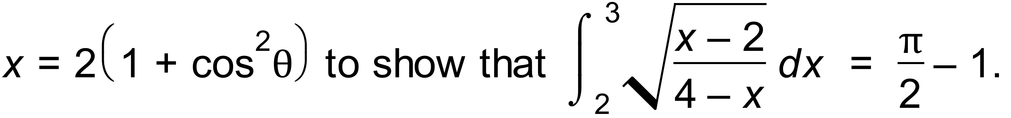

Question 4 (3 marks)
Find the equation of the tangent to the curve at the point (1, -2).

Question 5 (4 marks)
Using partial fractions, or otherwise, determine $\int{\frac{x-19}{(x+1)(x-4)}}dx$.

Calculator Assumed
Question 6 (7 marks)
The graph of $y=f(x)$ is shown below, where $f\left(x\right)={4cos}^{4}{(2x)}$ and A is the smallest root of $f\left(x\right), x>0$.
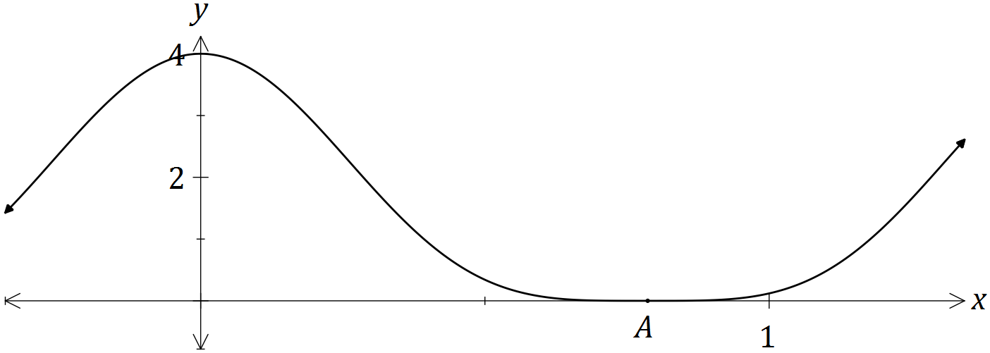

(a) Show that ${ 4cos}^{4}{(2x)} = \frac{3+4\cos{(4x)}+\cos{(8x)}}{2}$. (3 marks)

(b) Hence determine $\int{{4cos}^{4}{(2x)}}dx$. (2 marks)

(c) Determine the exact volume of the solid generated when the region bounded by $y=f\left(x\right),$ $y=0$, $x=0$ and $x=A$ is rotated through 360° about the x-axis. (2marks)

Question 7 (5 marks)

A four metre long water tank, open at the top, is in the shape of a triangular prism. The triangular face is a right isosceles triangle with congruent sides of one metre length.

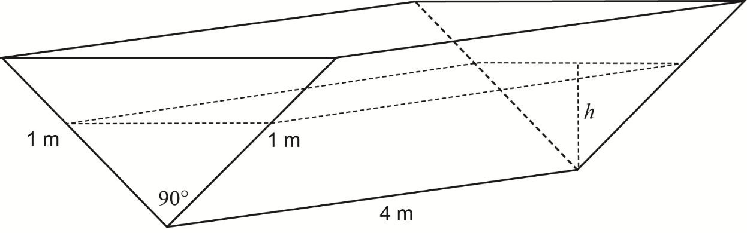

Initially the tank is completely full with water, but it develops a leak and loses water at a constant rate of 0.08 cubic metres per hour.
Let h = the depth of water, in metres, in the tank after t hours.
(a) Show that the volume of water in the tank V cubic metres, is given by the expression
$V\left(h\right)=4h^{2}.$ (2 marks)

(b) Determine the rate of change of the depth, correct to the nearest 0.01 metres per hour,
when the depth is 0.6 metres. (3 marks)

Question 8 (10 marks)
The Volume V of blood flowing through an artery in unit time can be modelled by the formula
$V=kr^{4}$, where $r$ is the radius of the artery and $k$ is a constant.
(a) What is the effect of the volume of blood flow if the radius of the artery is halved? (2 marks)

(b) Use the incremental formula to estimate the percentage decrease in the radius of a partially clogged artery that will produce a 10% decrease in the flow of blood. (5 marks)

(c) Show that the incremental formula gives a physically absurd estimate of the change in $V$ resulting from a halving of the radius of the artery. Explain why this estimate is so poor compared to the true answer found in (a). (3 marks)

